Testing the length of time in the schedule. The start time should always be earlier than the end time.

Results view:

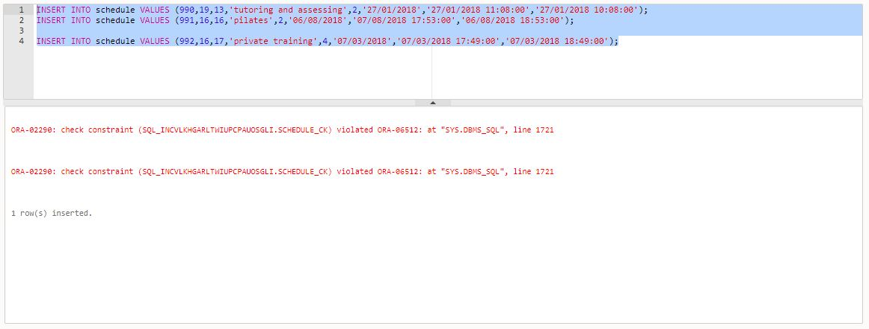

Testing the validity of the number at the place where the activity will take place.

Results view:

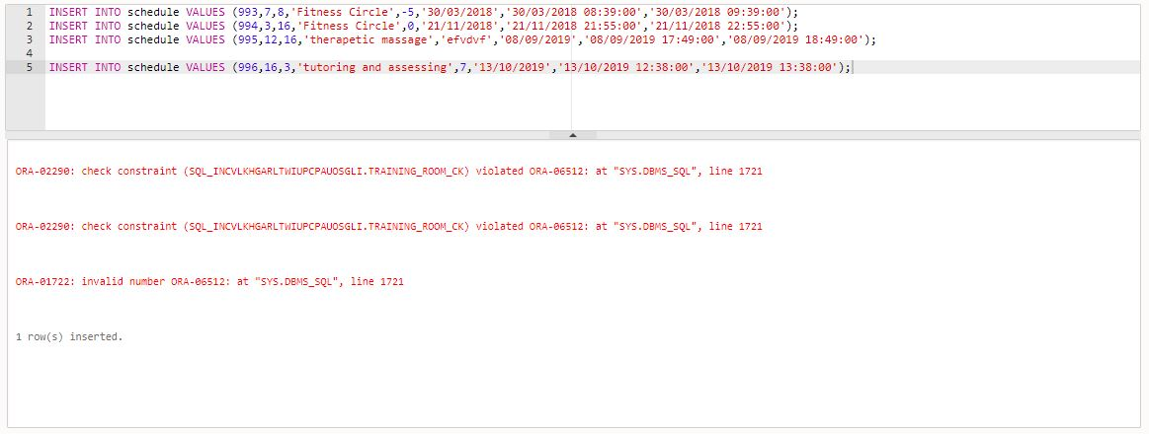

Dates validation tests.

Results view:

